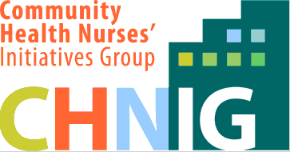


Application Form

CHNIG Professional Development Bursary

To Attend the Annual 2017 RNAO and CHNIG Annual AGMs
Title (circle one): Mr. Miss Ms. Mrs. Dr. Other:
Last Name: First Name:
Street:
City: Province: Postal Code:
Phone number (with area code): Home Work
Other
Email:
Position (circle one): Registered Nurse Undergraduate Nursing Student
RNAO Registration Number:
How long have you been a member of CHNIG? (include dates):
Current Employer, area of practice, position, role:

Please provide a brief personal summary with your application (<500 words)
Criteria for personal summary includes:
- RN with a minimum two year membership in CHNIG or a student with a minimum one year membership

- Evidence of involvement (past/present) in your professional association(s) (CHNIG, RNAO, CHNC, etc.).

- Please provide a paragraph outlining your professional objectives in attending the AGMs.

- ANTICIPATED EXPENSES: Provide an itemized list and description of anticipated expenses (i.e., mileage by car, price for GO train, hotel, meals, etc.).

- Strategies to share learning from the meetings with others (e.g. nursing colleagues, students, other health care professionals etc.).

- Please add the following to your document: “I certify that all information contained in this application is true and accurate,” followed by the date and your signature.

- Please send completed applications by Friday, April 14th, 2017 @11:59 pm to MemberBenefits@CHNIG.org.

Please note: Preference will be given to those who have NOT been previously funded or those seeking funding for the first time.

